**7-1 Project One Report**

Jasmine Zeng

Southern New Hampshire University

CS 350: Emerging Systems Architecture and Technology

Professor Alex Pettit

**Task Scheduler Documentation**

The app uses Task Scheduler to toggle LEDs with a GPIO interrupt mechanism. The following diagram shows the program’s logic:

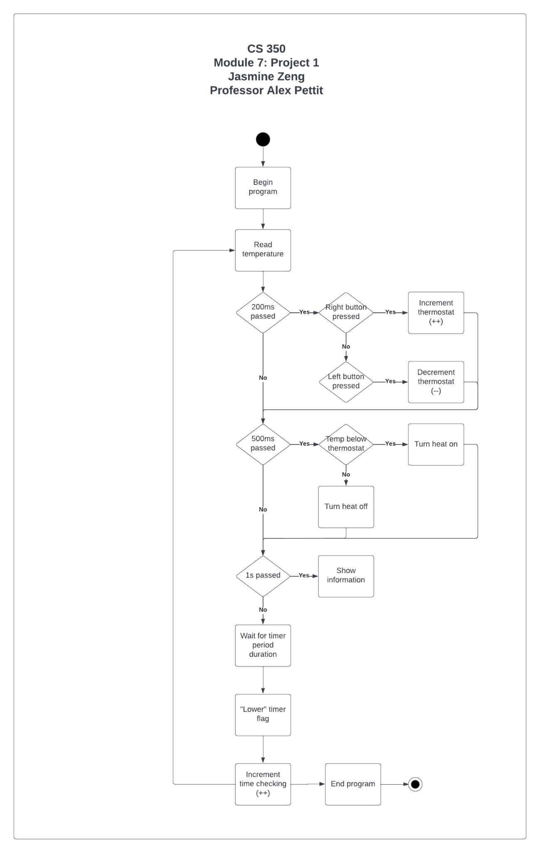

**Report: Peripherals, Cloud, and Flash & RAM**

The program uses files **ti_drivers_config.c** and **ti_drivers_config.h** to store generated TI driver configurations from the SysConfig tool. Pin and resource data are in both of these files. There is also an option to use the System Configuration file to see which pins and resources are used. The following tables shows inputs and outputs, and information on microcontroller architectures:

|  |  |
| --- | --- |
| **Variable Name** | **Notes** |
| CONFIG_GPIO_LED_0 | Indicates board initialization through mainThread() and/or CONFIG_GPIO_BUTTON_0 |
| CONFIG_GPIO_LED_1 | Toggled by CONFIG_GPIO_BUTTON_1 |
| CONFIG_GPIO_BUTTON_0 | Toggles CONFIG_GPIO_LED_0 |
| CONFIG_GPIO_BUTTON_1 | Toggles CONFIG_GPIO_LED_1 |

|  |  |  |
| --- | --- | --- |
| **Architecture** | **Flash & Ram** | **Cloud** |
| **TI** | * Provide on-demand controls in embedded technologies. * Multiple pins permit embedded technologies to be responsive. * Has microcontrollers to receive various kinds of input. | * Development tools are cloud based and allow microcontrollers to be connected and executed over the internet. * Dual band single-chip wireless MCU. * Allows for IoT development through supported SDKs. |
| **Microchip** | * Extended memory range and integrated peripherals. * Senses and responds to touch inputs. * Responsiveness also provides precise time measurement. | * Development tools are cloud based and allow microcontrollers to be connected and executed over the internet. * Outsources data computations to the cloud. |
| **Freescale** | * High performance and require very little power. * Offer wired and wireless communications. * Silicon insulator technology and single-chip blueprint allow network processing and control processing to happen in one place. | * Development tools are cloud based and allow microcontrollers to be connected and executed over the internet. * Connects to the cloud to compute and process data. |